CHTC Organic Certification Implementing Rule
Version 2022

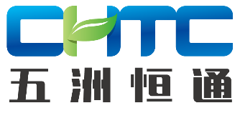
Content
1. Purpose and Scope 1
2. Parallel production 1
3. Derogation 1
3.1 Use of seed or vegetative propagating material not obtained by the organic production method 1
3.2 Conversion period 2
3.3 Authorisation of non-organic food ingredients of agricultural origin 3
4 Labelling 3
4.1 Organic logo of the EU 3
4.2 Conditions for the use of the code number and place of origin 3
4.3 In-conversion products of plant origin 3
5. Controls 4
5.1 Minimum control requirements 4
5.2 Specific control requirements for plants and plant products from farm production or collection 7
5.3 Control requirements for units for preparation of plant, seaweed, livestock and aquaculture animal products and foodstuffs composed thereof 7
5.4 Control requirements for units involved in the production, preparation or import of organic products and which have contracted out to third parties in part or in total the actual operations concerned 8
5.5 Infringements and exchange of information 8
5.6 Control on the certification 9
6. Certification Process 10
6.1 The prerequisite of a certification application acceptance by CBs 10
6.2 Application review 11
6.3 Inspection methods and techniques 11
6.4 Inspection report 12
6.5 Documentary evidence (Organic certificate) 12
6.6 Post-Certification Management 13
6.7 Certification Renewal 13
7. Information Reporting System 14
7.1 Publication of information 14
7.2 Report Obligations 14
8. Certificate of Inspection 14
8.1 definition 14
8.2 Verification in the third country 15
8.3 Issuance of the certification of inspection 16
8.4 Format of the certificate of inspection and use of TRACES 16
ANNEX I 18
ANNEX II 19

1. Purpose and Scope
1.1 Based on the provisions as specified in the EU organic regulation and CHTC organic standard, the Rules are formulated for the purposes of regulating certification activities of CHTC organic products.
1.2 The Rules specify the general requirements of control activities.
1.3 The activities shall comply with the Rules including certification, production, processing, importation, exportation and trade of organic products certified by CHTC.

2. Parallel production
When a producer run organic and non-organic production units in the same area in compliance with CHTC organic standard,
a) the conversion plan and the control measures shall be submitted to CHTC to get approved by CHTC;
b) this approval shall be confirmed each year after the start of the conversion plan;

3. Derogation

3.1 Use of seed or vegetative propagating material not obtained by the organic production method
Authorisation to use seed or seed potatoes not obtained by the organic production method may only be granted in the following cases:
(a) where no variety of the species which the user wants to obtain is registered in the seed database;
(b) where no supplier, meaning an operator who markets seed or seed potatoes to other operators, is able to deliver the seed or seed potatoes before sowing or planting in situations where the user has ordered the seed or seed potatoes in reasonable time;
(c) where the variety which the user wants to obtain is not registered in the database, and the user is able to demonstrate that none of the registered alternatives of the same species are appropriate and that the authorisation therefore is significant for his production;
(d) where it is justified for use in research, test in small-scale field trials or for variety conservation purposes agreed by the competent authority.
The authorisation shall be granted before the sowing of the crop.
The authorisation shall be granted only to individual users for one season at a time and CHTC is responsible for the authorisations shall register the quantities of seed or seed potatoes authorised.

3.2 Conversion period
3.2.1 CHTC may decide to recognise retroactively as being part of the conversion period any previous period in which:
(a) the land parcels were certified against national organic regulation provided that the measures concerned ensure that products not authorised for organic production have not been used on those parcels and the certificate is still valid when the operator submits the application.
(b) the parcels were natural or agricultural areas which were not treated with products not authorised for organic production.
The period referred to in point (b) of this subparagraph can be taken into consideration retroactively only where satisfactory proof has been furnished to the competent authority allowing it to satisfy itself that the conditions were met for a period of at least three years.
The operator shall submit the derogation application in written during the initial application. Otherwise, the recognition shall not be granted.
3.2.2 CHTC may decide, in certain cases, where the land had been contaminated with products not authorised for organic production, to extend the conversion period beyond the period referred to in CHTC organic standard.
3.2.3 In the case of parcels which have already been converted to or were in the process of conversion to organic farming, and which are treated with a product not authorised for organic production, CHTC may shorten the conversion period referred to in CHTC organic standard in the following two cases:
(a) parcels treated with a product not authorised for organic production as part of a compulsory disease or pest control measure imposed by the competent authority;
(b) parcels treated with a product not authorised for organic production as part of scientific tests approved by the competent authority.
In the cases provided for in points (a) and (b) of the this subparagraph, the length of the conversion period shall be fixed taking into account of the following factors: (a) the process of degradation of the product concerned shall guarantee, at the end of the conversion period, an insignificant level of residues in the soil and, in the case of a perennial crop, in the plant; (b) the harvest following the treatment may not be sold with reference to organic production methods.

3.3 Authorisation of non-organic food ingredients of agricultural origin
Where an ingredient of agricultural origin is not included in CHTC organic standard, that ingredient may only be used under the following conditions:
(a) the operator has notified to CHTC all the requisite evidence showing that the ingredient concerned is not produced in sufficient quantity in the third country in accordance with the organic production rules or cannot be imported from other countries;
(b) CHTC has provisionally authorised, the use for a maximum period of 12 months after having verified that the operator has undertaken the necessary contacts with suppliers in the third country to ensure himself of the unavailability of the ingredients concerned with the required quality requirements;
(c) no decision has been taken, that a granted authorisation with regard to the ingredient concerned shall be withdrawn.
CHTC may prolong the authorisation provided for in point (b) a maximum of three times for 12 months each.

4 Labelling

4.1 Organic logo of the EU
In accordance with EU organic regulation, the organic production logo of the European Union (hereinafter ‘Organic logo of the EU’) shall follow the model set out in according to that regulation.
For the purpose of labelling, the organic logo of the EU shall only be used if the product concerned is certified organic.

4.2 Conditions for the use of the code number and place of origin
1. The indication of the code number of CHTC shall be placed in the same visual field as the Organic logo of the EU, where the Organic logo of the EU is used in the labelling.
2. The indication of the place where the agricultural raw materials of which the products are composed have been farmed shall be placed immediately below the code number referred to in paragraph 1.

4.3 In-conversion products of plant origin
Products with organic conversion certificate shall only be sold as conventional products. Neither organic logo of EU nor any descriptive words and pattern of “有机”/ ”ORGANIC” shall be used thereon.

5. Controls

5.1 Minimum control requirements

5.1.1 Control arrangements and undertaking by the operator
1. When the control arrangements are first implemented, the operator shall draw up and subsequently maintain:
(a) a full description of the unit and/or premises and/or activity;
(b) all the practical measures to be taken at the level of the unit and/or premises and/or activity to ensure compliance with the organic production rules;
(c) the precautionary measures to be taken in order to reduce the risk of contamination by unauthorised products or substances and the cleaning measures to be taken in storage places and throughout the operator's production chain;
(d) the specific characteristics of the production method used, where the operator intends to request certificate.
Where appropriate, the description and measures provided may be part of a quality system as set up by the operator.
2. The description and the measures referred to in paragraph 1 shall be contained in a declaration, signed by the responsible operator. In addition, this declaration shall include an undertaking by the operator:
(a) to perform the operations in accordance with the organic production rules;
(b) to accept, in the event of infringement or irregularities, the enforcement of the measures of the organic production rules;
(c) to undertake to inform in writing the buyers of the product in order to ensure that the indications referring to the organic production method are removed from this production;
(d) to accept, in cases where the operator and/or the subcontractors of that operator are checked by different CBs, the exchange of information between those authorities or bodies;
(e) to accept, in cases where the operator and/or the subcontractors of that operator change their CB, the transmission of their control files to the subsequent CB;
(f) to accept, in cases where the operator withdraws from the control system, to inform without delay CHTC;
(g) to accept, in cases where the operator withdraws from the control system, that the control file is kept for a period of at least five years;
(h) to accept to inform the relevant control authority or authorities or control body or bodies without delay of any irregularity or infringement affecting the organic status of their product or organic products received from other operators or subcontractors.
The declaration provided for in the first subparagraph shall be verified by CHTC that issues a report identifying the possible deficiencies and non-compliances with the organic production rules. The operator shall countersign this report and take the necessary corrective measures.

5.1.2 Updates submitted by the operator
The operator responsible shall notify any change in the description or of the measures referred to in 6.1.1 and in the control arrangements to CHTC in due time.

5.1.3 Control Visits
1. A physical inspection of all operators shall be carried once a year.
In any case, all operators with the exception of wholesalers dealing only with pre-packaged products and operators selling to the final consumer or user provided they do not produce, prepare, store other than in connection with the point of sale, shall be subject to a verification of compliance at least once a year.
2. Samples shall be taken and analyses for detecting of products not authorised for organic production, for checking production techniques not in conformity with the organic production rules or for detecting possible contamination by products not authorised for organic production. The number of samples to be taken and analysed by CHTC every year shall correspond to at least 5 % of the number of operators under its control. The selection of the operators where samples have to be taken shall be based on the general evaluation of the risk of non-compliance with the organic production rules. This general evaluation shall take into account all stages of production, preparation and distribution.
CHTC shall take and analyse samples in each case where the use of products or techniques not authorised for organic production is suspected. In such cases no minimum number of samples to be taken and analysed shall apply.
Samples may also be taken and analysed by CHTC in any other case for detecting of products not authorised for organic production, for checking production techniques not in conformity with the organic production rules or for detecting possible contamination by products not authorised for organic production.
3. A control report shall be drawn up after each visit, countersigned by the operator of the unit or his representative.
4. Moreover, random control visits shall be carried out, primarily unannounced, based on the general evaluation of the risk of non-compliance with the organic production rules, taking into account at least the results of previous controls, the quantity of products concerned and the risk for exchange of products.

5.1.4 Documentary account
1. Stock and financial records shall be kept in the unit or premises and shall enable the operator to identify and the CHTC to verify:
(a) the supplier and, where different, the seller, or the exporter of the products;
(b) the nature and the quantities of organic products delivered to the unit and, where relevant, of all materials bought and the use of such materials, and, where relevant, the composition of the compound feedingstuffs;
(c) the nature and the quantities of organic products held in storage at the premises;
(d) the nature, the quantities and the consignees and, where different, the buyers, other than the final consumers, of any products which have left the unit or the first consignee's premises or storage facilities;
(e) in case of operators who do not store or physically handle such organic products, the nature and the quantities of organic products bought and sold, and the suppliers, and where different, the sellers or the exporters and the buyers, and where different, the consignees.
2. The documentary accounts shall also comprise the results of the verification at reception of organic products and any other information required by CHTC for the purpose of proper control. The data in the accounts shall be documented with appropriate justification documents. The accounts shall demonstrate the balance between the input and the output.

5.1.5 Access to facilities
1. The operator shall:
(a) give CHTC, for control purposes, access to all parts of the unit and all premises, as well as to the accounts and relevant supporting documents;
(b) provide CHTC with any information reasonably necessary for the purposes of the control;
(c) submit, when requested by CHTC, the results of its own quality assurance programmes.
2. In addition to the requirements set out in paragraph 1, importers and first consignees shall submit the information on imported consignments referred to in 5.1.4, 5.1.1, organic certificate and TC.

5.1.6 Documentary evidence (organic certificate)
The model of the documentary evidence is set out in Annex I.

5.1.7 Operator with several production units
Where an operator runs several production units in the same area, the units for non organic products, together with storage premises for input products must also be subject to the minimum control requirements.

5.2 Specific control requirements for plants and plant products from farm production or collection

5.2.1 Control arrangements
1. The full description of the unit referred to in 5.1.1 (1)(a) shall:
(a) be drawn up even where the operator limits his activity to the collection of wild plants;
(b) indicate the storage and production premises and land parcels and/or collection areas and, where applicable, premises where certain processing and/or packaging operations take place; and
(c) specify the date of the last application on the parcels and/or collection areas concerned of products, the use of which is not compatible with the organic production rules.
2. In case of collection of wild plants, the practical measures referred to in 5.1.1 (1)(b) shall include any guarantees given by third parties which the operator can provide to ensure that those areas have not been treated prohibited substance for at least 3 years and the collection doesn’t affect the stability of natural habitat.

5.2.2 Communications
Each year, before the date indicated by CHTC, the operator shall notify CHTC of its schedule of production of crop products, giving a breakdown by parcel.

5.3 Control requirements for units for preparation of plant, seaweed, livestock and aquaculture animal products and foodstuffs composed thereof

5.3.1 Control arrangements
In the case of a unit involved in the preparation for its own account or for account of a third party, and including in particular units involved in packaging and/or re-packaging of such products or units involved in labelling and/or re-labelling of such products, the full description of the unit referred to in 5.1.1 (1)(a) shall show the facilities used for the reception, the processing, packaging, labelling and storage of agricultural products before and after the operations concerning them, as well as the procedures for the transport of the products.

5.4 Control requirements for units involved in the production, preparation or import of organic products and which have contracted out to third parties in part or in total the actual operations concerned

5.4.1 Control arrangements
With regard to the operations, which are contracted out to third parties, the full description of the unit referred to in 5.1.1 (1)(a) shall include:
(a) a list of the subcontractors with a description of their activities and an indication of the control bodies or authorities to which they are subject;
(b) written agreement by the subcontractors that their holding will be subject to the control regime;
(c) all the practical measures, including inter alia an appropriate system of documentary accounts, to be taken at the level of the unit to ensure that the products the operator places on the market can be traced to, as appropriate, their suppliers, sellers, consignees and buyers.

5.5 Infringements and exchange of information

5.5.1 Measures in case of suspicion of infringements and irregularities
1. Where an operator considers or suspects that a product which he has produced, prepared, imported or that he has received from another operator, is not in compliance with organic production rules, he shall initiate procedures either to withdraw from this product any reference to the organic production method or to separate and identify the product. He may only put it into processing or packaging or on the market after elimination of that doubt, unless it is placed on the market without indication referring to the organic production method. In case of such doubt, the operator shall immediately inform CHTC. CHTC may require that the product cannot be placed on the market with indications referring to the organic production method until it is satisfied, by the information received from the operator or from other sources, that the doubt has been eliminated.
2. Where CHTC has a substantiated suspicion that an operator intends to place on the market a product not in compliance with the organic production rules but bearing a reference to the organic production method, CHTC can require that the operator may provisionally not market the product with this reference for a time period to be set by CHTC. Before taking such a decision, CHTC shall allow the operator to comment. This decision shall be supplemented by the obligation to withdraw from this product any reference to the organic production method if CHTC is sure that the product does not fulfill the requirements of organic production.
However, if the suspicion is not confirmed within the said time period, the decision referred to in the first subparagraph shall be cancelled not later than the expiry of that time period. The operator shall cooperate fully with CHTC in resolving the suspicion.

5.5.2 Exchange of information between control authorities, control bodies and competent authorities
1. Where the operator and/or the subcontractors of that operator are checked by different control bodies, CHTC shall exchange the relevant information on the operations under their control.
2. Where operators and/or their subcontractors change their control body, the change shall be notified without delay to CHTC.
Where the operator transfers in to CHTC, CHTC shall require the previous control authority or control body hand over the relevant elements of the control file of the operator concerned and the reports referred to in the second subparagraph of 5.1.1 (2). The CHTC shall ensure that non-conformities noted in the report of the previous control authority or control body have been or are being addressed by the operator.
Where the operator transfers out from CHTC, control files shall only share to the new control body once requested in written.
3. Where the operator withdraws from the control system, it shall, without delay, inform CHTC.

5.6 Control on the certification

5.6.1 Risk analysis
CHTC’s risk analysis procedure shall be established and documented.
The risk analysis procedure shall be designed in such a way that:
(a) the result of the risk analysis provides the basis for determining the intensity of the unannounced or announced annual inspections and visits;
(b) additional random control visits carried out in accordance with 5.1.3 (4) of at least 10 % of operators under contract in accordance with the risk category are performed;
(c) at least 10 % of all inspections and visits carried out in accordance with 5.1.3 (1) and (4) are unannounced;
(d) the selection of operators to be submitted to unannounced inspections and visits is determined on the basis of the risk analysis and that these are planned according to the level of risk.

5.6.2 Catalogue of measures in case of irregularities and infringements
A catalogue at least listing infringements and irregularities affecting the organic status of products and corresponding measures to be applied by CHTC shall be established, in case of infringements or irregularities by operators under their control who are involved in organic production.

5.6.3 Annual inspection of control bodies
a) CHTC’s standard control procedure shall be established and documented.
b) A sufficient number of suitable qualified and experienced staff shall be employed and trained concerning risks affecting the organic status of products has been implemented;
(c) CHTC shall have and follows documented procedures and templates for:
(i) the annual risk analysis. The nature and frequency of the controls shall be determined on the basis of an assessment of the risk of occurrence of irregularities and infringements as regards compliance with the requirements.
(ii) preparing a risk-based sampling strategy, conducting sampling and laboratory analysis;
(iii) information exchange with other control bodies and with the competent authority;
(iv) initial and follow-up controls of operators under their control;
(v) the application and follow-up to the catalogue of measures to be applied in case of infringements or irregularities;
(vi) observing the requirements of the protection of personal data for the operators under its control.

6. Certification Process

6.1 The prerequisite of a certification application acceptance by CBs
6.1.1 Products produced and processed by applicants and stakeholders shall comply with requirements of relevant laws and regulations, standards and technical specifications for quality, safety and sanitation.
6.1.2 Applicants shall submit at least documents and files required in 5.1.1, 5.2.1, 5.3.1, 5.4.1.
6.1.3 During on-site inspection, the inspection team shall review the compliance of applicant management system with the requirements of certification basis, verify the consistency of production/processing with documents submitted by applicants, and confirm the compliance of production/processing with certification basis.

6.2 Application review
The declaration provided by the operator shall be verified by CHTC that issues a report identifying the possible deficiencies and non-compliances with the organic production rules. The operator shall countersign this report and take the necessary corrective measures.

6.3 Inspection methods and techniques
Official control methods and techniques shall include the following as appropriate:
(a) an examination of the controls that operators have put in place and of the results obtained;
(b) an inspection of:
(i) equipment, means of transport, premises and other places under their control and their surroundings;
(ii) animals and goods, including semi-finished goods, raw materials, ingredients, processing aids and other products used for the preparation and production of goods or for feeding or treating animals;
(iii) cleaning and maintenance products and processes;
(iv) traceability, labelling, presentation, advertising and relevant packaging materials including materials intended to come into contact with food;
(c) controls on the hygiene conditions in the operators’ premises;
(d) an assessment of procedures on good manufacturing practices, good hygiene practices, good farming practices;
(e) an examination of documents, traceability records and other records which may be relevant to the assessment of compliance with the rules, including, where appropriate, documents accompanying food, feed and any substance or material entering or leaving an establishment;
(f) interviews with operators and with their staff;
(g) the verification of measurements taken by the operator and other test results;
(h) sampling, analysis, diagnosis and tests;
(i) audits of operators;
(j) any other activity required to identify cases of non-compliance.

6.4 Inspection report
1. Written records of every official control that CHTC perform shall be drawn up. Those records may be on paper or in electronic form.
Those records shall contain:
a description of the purpose of the official controls;
the control methods applied;
the outcome of the official controls; and
where appropriate, action that CHTC requires the operator concerned to take as a result of their official controls.
2. The operator shall be promptly informed in writing by CHTC of any case of noncompliance identified through the official controls.
3. The records provided for in paragraph 1 shall be produced with a frequency that enables CHTC and the operator to be:
(a) regularly informed of the level of compliance; and
(b) promptly informed of any case of non-compliance identified through the official controls.

6.5 Documentary evidence (Organic certificate)
CHTC shall provide documentary evidence to any such operator who is subject to its controls and who in the sphere of his activities, meets the requirements laid down in CHTC organic standard. The documentary evidence shall at least permit the identification of the operator and the type or range of products as well as the period of validity.
Documentary evidence (Organic certificates) shall:
(a) bear a unique code;
(b) not be signed by the GM where they are blank or incomplete;
(c) be drawn up in Chinese and English;
(d) be authentic and accurate;
(e) allow for the identification of the person who signed them and the date of issue; and
(f) allow the easy verification of the links between the certificate, CHTC and the consignment, lot or individual animal or good covered by the certificate.
The model of the documentary evidence is set out in Annex I.

6.6 Post-Certification Management
(a) Additional random control visits carried out in accordance with 5.1.3 (4) of at least 10 % of operators under contract in accordance with the risk category shall be performed annually;
(b) At least 10 % of all inspections and visits carried out in accordance with 5.1.3 (1) and (4) shall be unannounced;
(c) The number of samples to be taken and analysed by CHTC every year shall correspond to at least 5 % of the number of operators under its control.

6.7 Certification Renewal
6.7.1 Certified operator shall submit annual update before the date indicated by CHTC.
6.7.2 Recertification inspection shall be carried out prior to the certificate expiry date.
6.7.3 The renewal of the certificate shall be based on the results of the official control.
6.7.4 If recertification cannot be carried out as scheduled due to production season or serious natural disaster, the certified operator shall submit a written application with explanations to CHTC prior to the certificate expiry date. After confirmation and approval by CHTC, recertification shall be arranged within no more than 3 months after the certificate expiry date. The products produced in this period cannot be sold as organic.
6.7.5 The production units shall be deemed as an initial certification if certification renewal can not be implemented 3 months after the certificate expiry date.

7. Information Reporting System

7.1 Publication of information
CHTC shall keep an updated list containing the names and addresses of operators under their control.
This list shall be made available to the interested parties by electronic means, a continuously updated list of operators, and of products certified as organic.

7.2 Report Obligations
CHTC shall fulfils the following obligations to maintain the approval by EU commission:
(a) any changes are made to the measures applied by CHTC, CHTC shall notify the Commission thereof;
(b) by 28 February every year, CHTC shall send a concise annual report to the Commission. The annual report shall update the information of the technical dossier; it shall describe in particular the control activities carried out by CHTC in the third countries in the previous year, the results obtained, the irregularities and infringements observed and the corrective measures taken; It shall furthermore contain the most recent assessment report or update of such report, which shall contain the results of the regular on-the-spot evaluation, surveillance and multiannual reassessment.

8. Certificate of Inspection

8.1 definition
‘certificate of inspection’: means the certificate of inspection covering one consignment.
CHTC is only responsible for issuing the COI when it is:
- the control body of the producer or the processor of the product concerned; or
- where the operator or group of operators carrying out the last operation for the purpose of preparation is different from the producer or processor of the product, the control body of the operator or group of operators carrying out the last operation for the purpose of preparation as defined in point (44) of Article 3 of Regulation (EU) 2018/848.

8.2 Verification in the third country
8.2.1 CHTC shall verify the consignment after receiving the COI application from the certified operator. This verification shall include systematic documentary checks and, as appropriate according to a risk assessment, physical checks, before the consignment leaves the third country of export or of origin.
8.2.2 The documentary checks referred to in 8.2.1 shall aim at verifying:
(a) the traceability of the products and ingredients;
(b) that the volume of the products included in the consignment is in line with the mass balance checks of the respective operators or groups of operators according to the assessment carried out by CHTC;
(c) the relevant transport documents and commercial documents (including invoices) of the products;
(d) in case of processed products, that all organic ingredients of such products have been produced by operators or groups of operators certified EU organic.
Those documentary checks shall be based on all relevant documents, including the organic certificate, the latest record of the inspections, the production plan for the product concerned and records kept by the operators or groups of operators, available transport documents, commercial and financial documents and any other documents deemed relevant by CHTC.
8.2.3 In relation to the risk assessment preceding physical checks as referred to in 8.2.1, CHTC shall take into account the following criteria:
- the relevant criteria listed in Article 9(2) of EU 2021/1698;
- whether there are several operators involved in the distribution chain of the products who do not store or physically handle organic products;
- high-risk products deemed by EU commission;
- any criteria deemed relevant by CHTC.
8.2.4 For consignments made out of bulk organic products, a travel plan shall be drawn up in the Trade Control and Expert System (TRACES), including all the premises to be used during the travel from the third country of origin or export to the Union.
8.2.5 For consignments of high-risk products deemed by EU commission, CHTC shall carry out systematic physical checks and take at least one representative sample of each consignment. Moreover, CHTC shall have complete documentation of the traceability of the operators or groups of operators and the product, including transport and commercial documents, including invoices. At the request of the Commission or the competent authority of a Member State, CHTC shall send this traceability documentation as well as the results of the sampling analysis to the control authority or control body of the importer and to the competent authority of the Member State where the consignment is verified.
8.2.6 In case of suspicion of non-compliance, CHTC shall provide relevant information to the Commission or the competent authority of a Member State as requested.

8.3 Issuance of the certification of inspection
8.3.1 A certificate of inspection shall be issued by CHTC in accordance with 8.4 for every consignment before the consignment leaves the third country of export or of origin.
8.3.2 The certificate of inspection for consignments containing high risk products only once CHTC is in possession of the complete documentation of the traceability and it has received and assessed the results of the analyses of the samples taken on the consignment.

8.4 Format of the certificate of inspection and use of TRACES
8.4.1 CHTC shall issue in the Trade Control and Expert System (TRACES) the certificate of inspection in accordance with the model and the notes set out in the Annex II and shall complete boxes 1 to 18 of that certificate.
8.4.2 When issuing the certificate of inspection, CHTC shall upload into TRACES all the supporting documents, including the following:
- the results of analyses or tests carried out on the samples taken, where applicable;
- the commercial and transport documents such as the bill of lading, invoices and packaging list and, the travel plan as drawn up.
8.4.3 The certificate of inspection shall be issued in TRACES and shall bear a qualified electronic seal.
If unavailable at the moment of the issuance, the information relating to the number of packages referred to in box 13 of the certificate of inspection and the information referred to in boxes 16 and 17 thereof, as well as the documents referred to in paragraph 2, shall be included or updated in the certificate of inspection within 10 days from its issuance and, in any case, before its verification and endorsement by the competent authority at a border control post or at a point of release for free circulation.
8.4.4 The certificate of inspection shall be drawn up:
(a) in English or in one of the official languages of the Member State of the border control post of entry into the Union, in the case of products subject to official controls at border control posts;
(b) in English or in one of the official languages of the Member State where the consignment is to be released for free circulation, in the case of products exempted from official controls at border control posts in accordance with Delegated Regulation (EU) 2021/2305.

ANNEX I
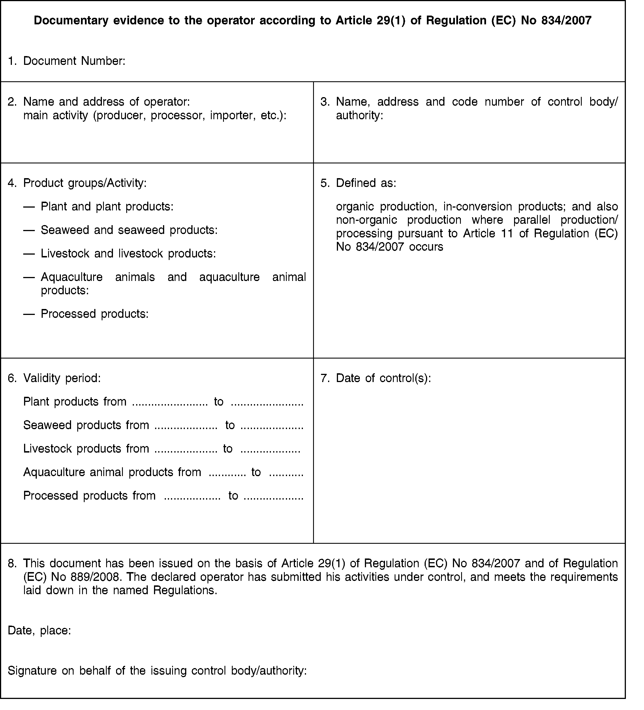

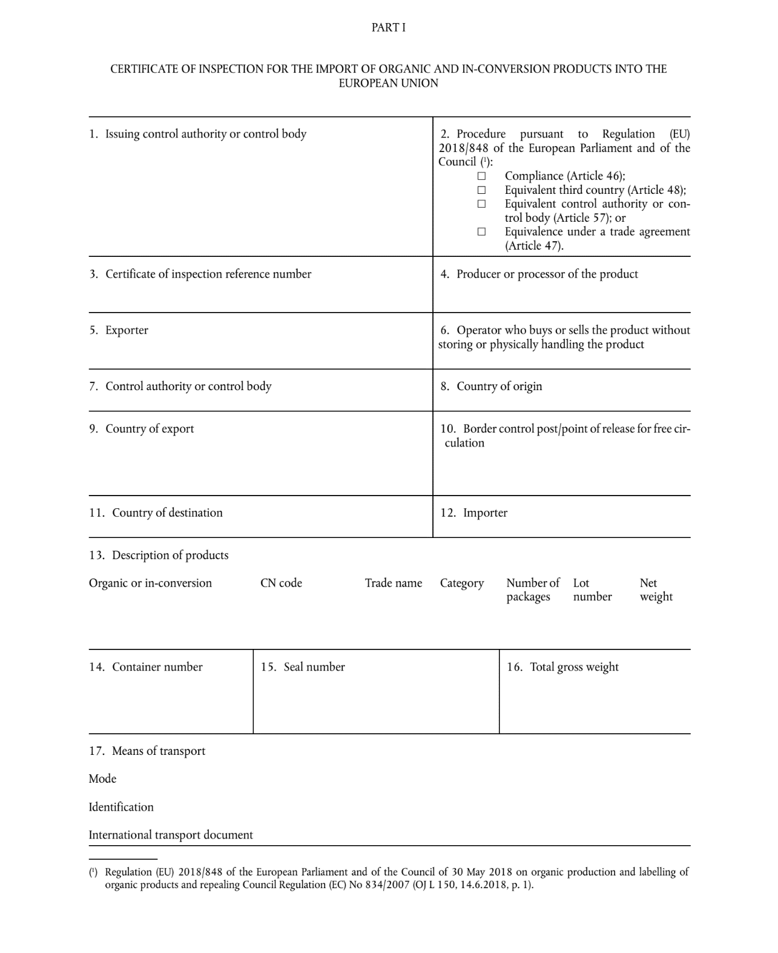
ANNEX II
